1. **WebCrawler to check email links in Lab6_Webpage.html**

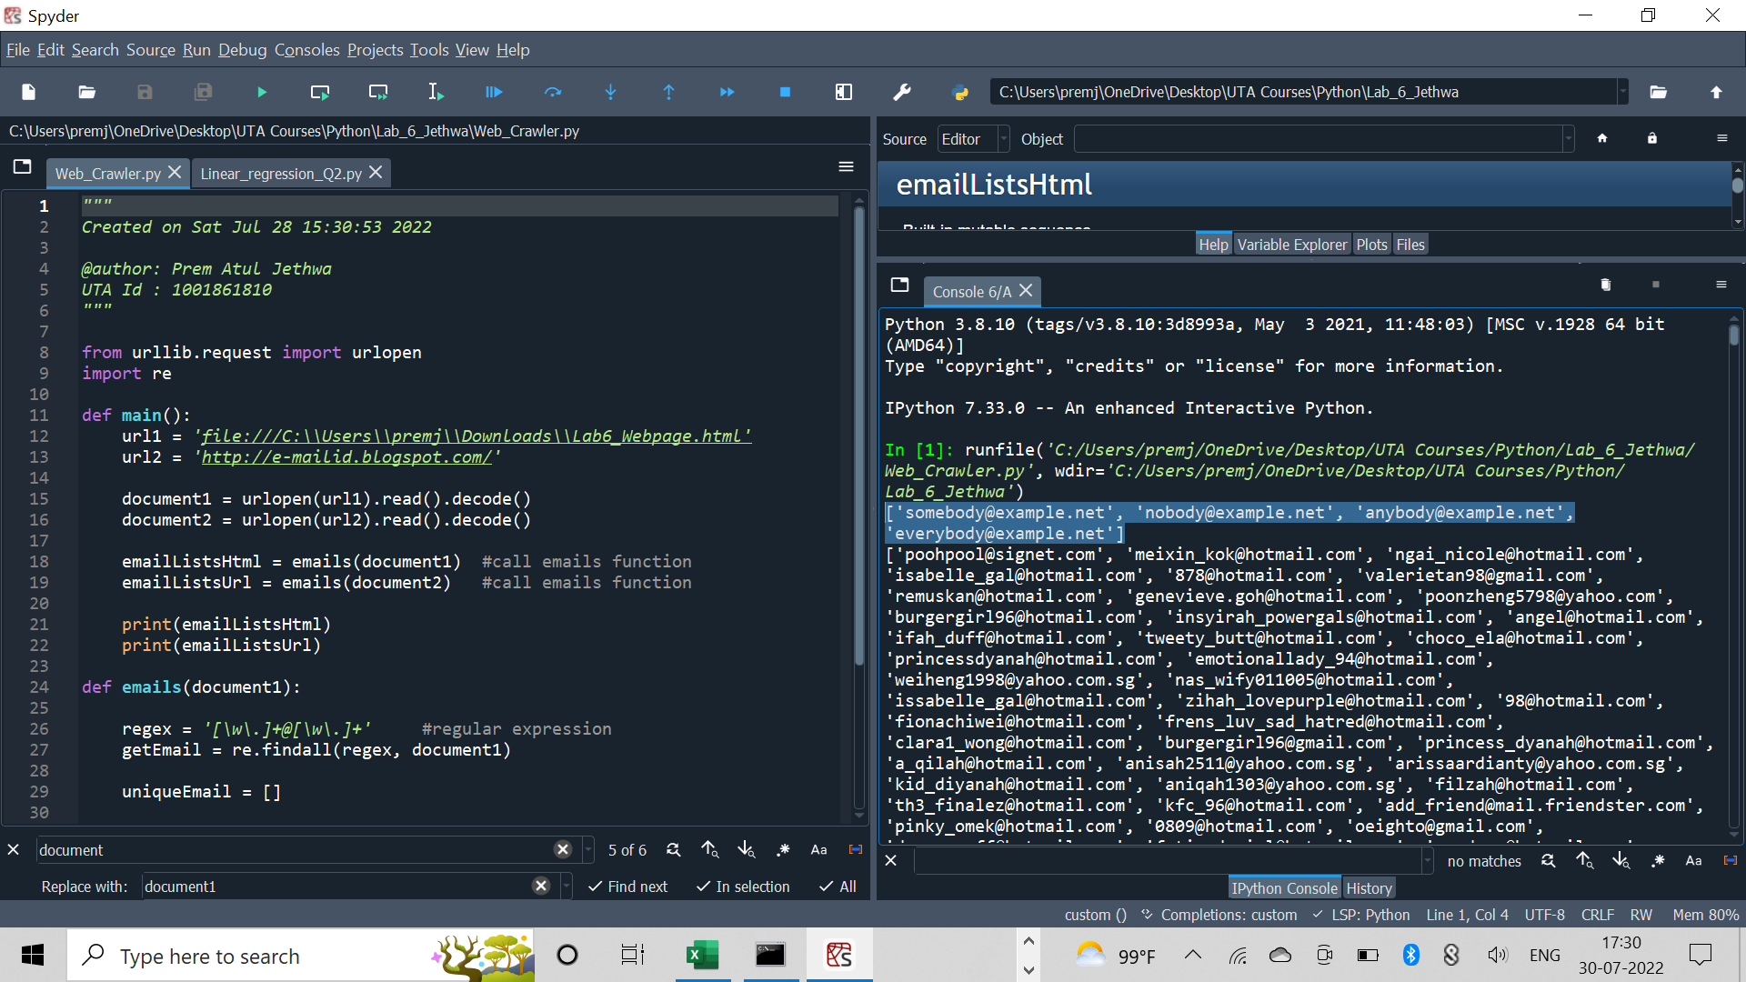

1. **WebCrawler to check email links in given sample URL**



